Conserving Vermont’s Reptiles
Instructor: Jim Andrews
January through May 2022

Learn the identification, natural history, survey techniques, conservation, and management of Vermont’s turtles, snakes, and lizards with herpetologist Jim Andrews. The class will begin with five remote Zoom presentations and then finish with three field trips. We will find and discuss a selection of Vermont’s reptiles while reviewing the material in the lectures and discussing conservation management. Remote Zoom classes will be held from 7 PM to 8:30 PM Monday evenings and consist of PowerPoint presentations and video clips. The field trips will begin with one Saturday-Sunday weekend and be followed up by a Saturday trip (see itinerary). Our field trips will visit reptile habitat in west-central Vermont. This class is not graded and there is no homework but you will be encouraged to get out on your own, document some Vermont reptiles, and apply some reptile conservation measures.

The class is open to the public and designed for adult professionals working in land management and conservation, naturalists of all levels, and life-long learners. The field trips will be off trail but only moderately challenging.

Past students have used this course to meet various certification credit requirements for professional development.
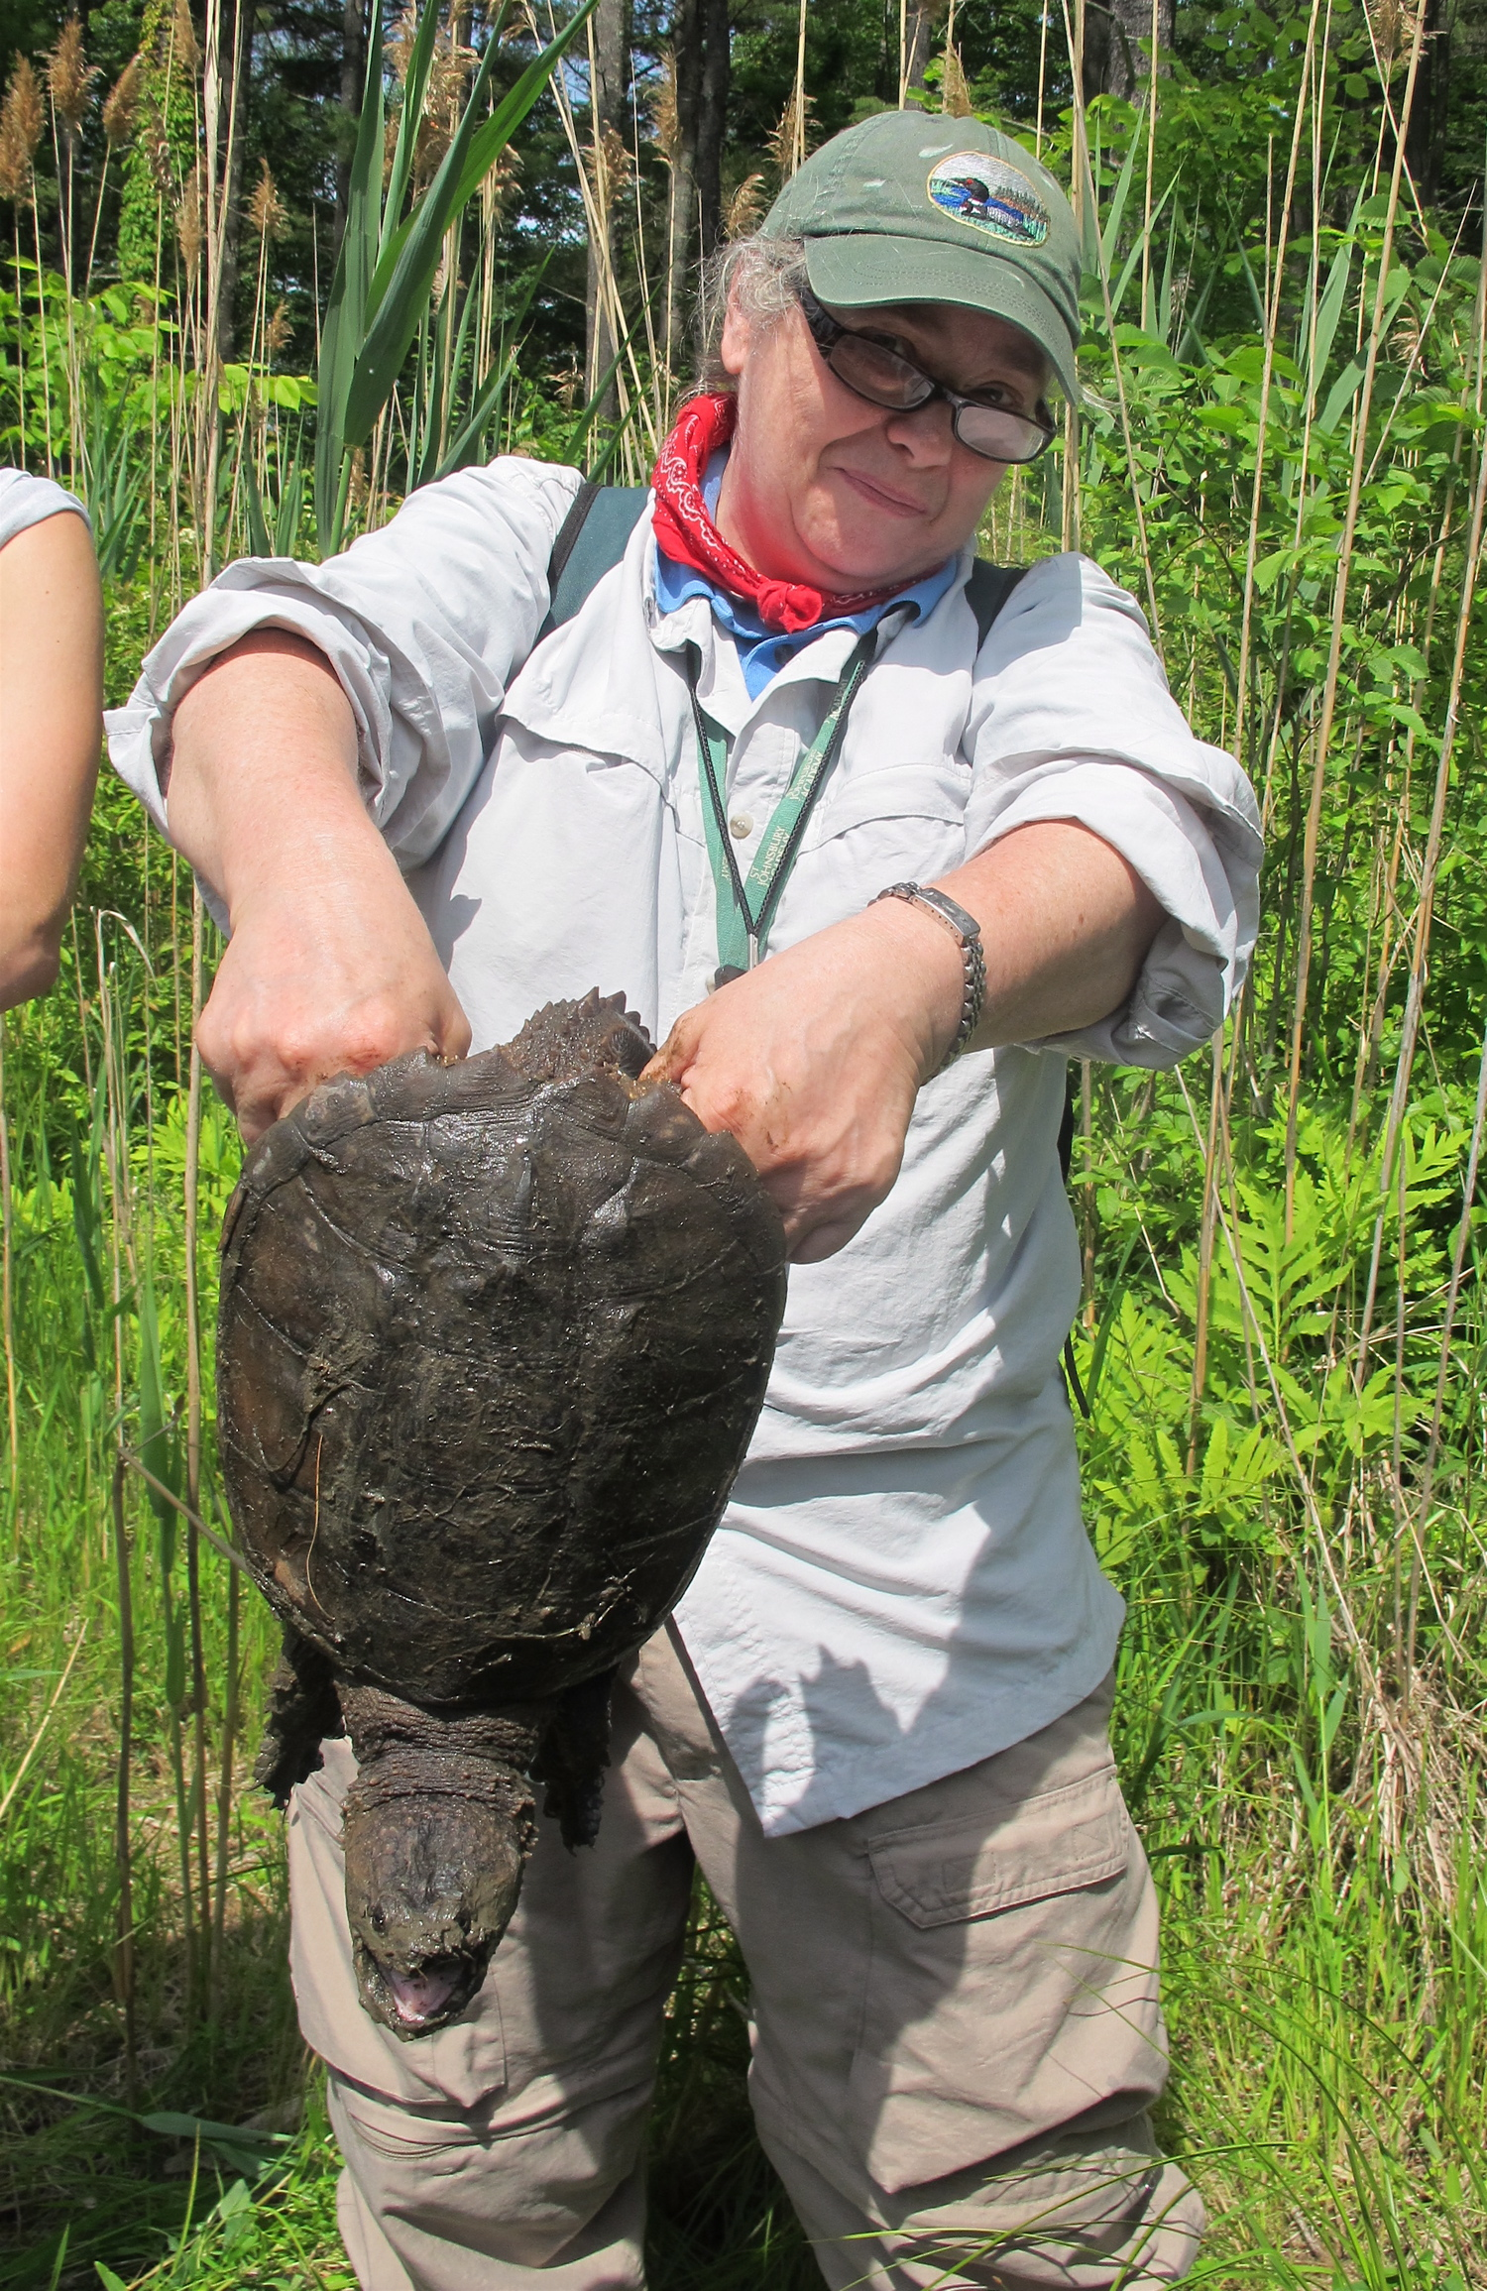 | 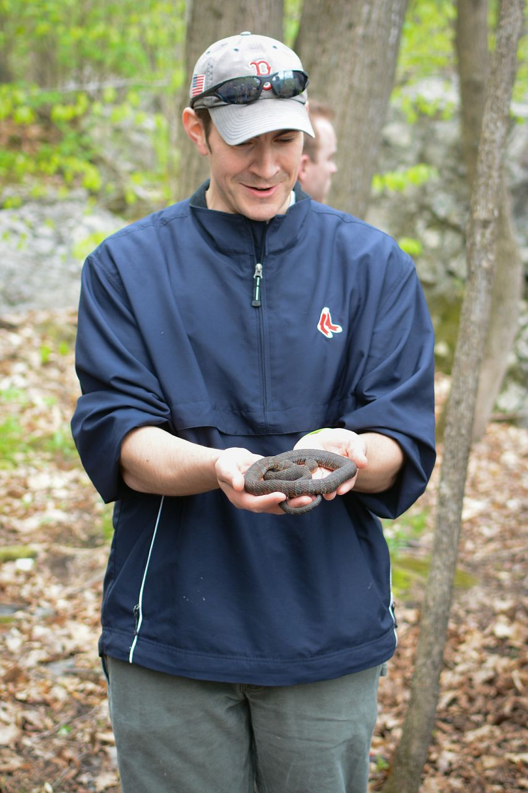 | 