802-352-4734 | 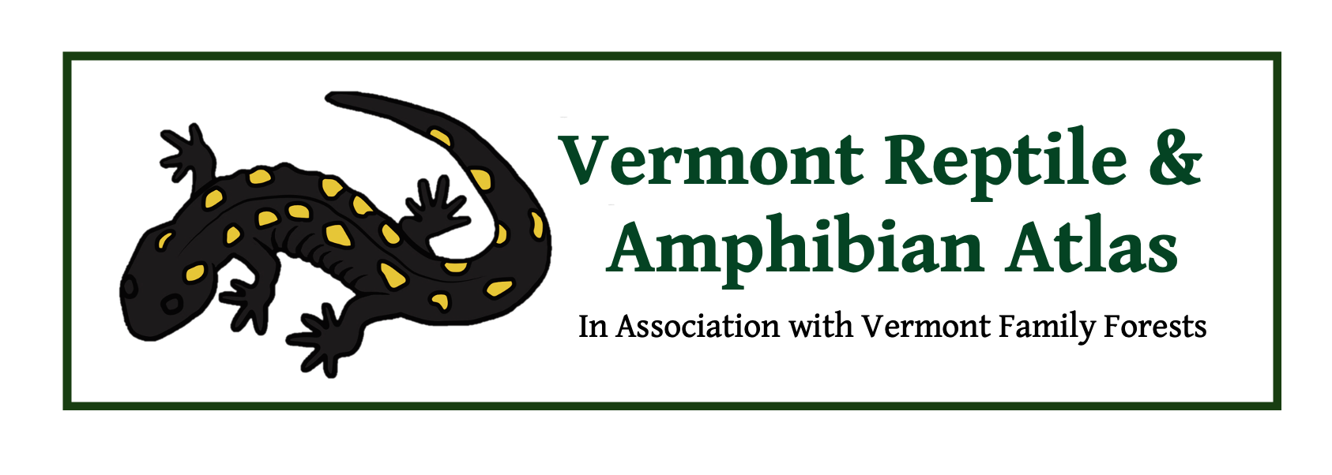 | VtHerpAtlas.org

It is time for our 2021 Fund Raiser

Two years ago we organized our first fundraiser. It was motivated by a decline in our regular grant funding and a pressing need to get all our data online for future use and assign accurate latitude and longitude coordinates to older records. The fundraiser was a huge success, so we tried it again the following year. We now plan to hold an annual winter fundraiser to raise $20,000 to support HerpAtlas projects that are not adequately funded by our grants.

I hope you will contribute!

Donations can be made in a few ways:

- Through our GoFundMe site at:
https://www.gofundme.com/f/vermont-reptile-amphibian-atlas-fundraiser-21
They take 2.9 percent of the payment plus 30 cents per transaction.

- You can now contribute using the PayPal button at our website:
https://www.paypal.com/paypalme/VtHerpAtlas
They take 2.9 percent of the payment plus 30 cents per transaction.

- You can send a check made out to James S. Andrews to the address below.
No overhead is lost.

- You can donate directly to a registered 501c3 non-profit by making a check out to Vermont Family Forests and sending it to the address below.
They take 15% for overhead costs.

Any checks should be sent to:

The Vermont Reptile and Amphibian Atlas
642 Smead Road
Salisbury, VT

Bling

We have some gifts to offer you for your contribution. Please let us know when you contribute, if you would like your gift.

- $50-$99: Herp Atlas bumper sticker
- $100-$199: Herp Atlas bumper sticker and our Herp Atlas refrigerator magnet
- $200-$999: You will be entered into a drawing for a group field trip for you and up to 10 friends
- $1000 Plus: Private field trip for you and up to ten friends

The full 2020 Vermont Reptile and Amphibian Atlas annual report is attached. I have included a short version below.

Ongoing goals for 2021

The ultimate goal of the Atlas is to gather and disseminate the data that are needed on the reptiles and amphibians of Vermont in a way that involves and informs Vermont individuals and organizations so that they can become more informed and effective stewards of wildlife habitat.

Short-term goals for 2021

- Finish scanning the last of the paper reports and organize and reference them online.

- Begin scanning old slides and photo prints of Vermont reptiles and amphibians and organize and reference them online.

- Replace our two office computers and update their software.

- Gather survey reports from those towns we have not surveyed in the last 25 years (e.g., Newark, Wardsboro, Topsham, Averill, Buels Gore, Montgomery, & West Windsor).

What progress did we make on our short-term goals for 2020?

- Coordinates: we exceeded our expectations by adding lat long coordinates not only to the more unusual state heritage rank S1-S3 species, but all S4 species as well. This is over 75,000 of 113,000 records.

- Archiving Records: we have now organized and scanned all the original reports that we had filed in our species folders and they have been referenced in the online records in our database. This puts us about ¾ of the way through the scanning and labelling process.

- Update of the Website/Printed Atlas/Printed Posters: we recently printed copies of our 2019 update of The Vermont Reptile and Amphibian Atlas. We also have updated all four of our posters on the reptiles and amphibians of Vermont. All of these items will soon be available through our website.

What progress did we make on our long-term project work in 2020?

Contributed records: Between January 1, 2020 and December 30, 2020 over 900 contributors provided over 3,600 new records that were entered into the Vermont Reptile and Amphibian Atlas Database. This brings the total number of reports entered to 113,296.

- Targeted survey efforts: in 2020, we personally visited over 25 towns to gather new records.

- Field trips, presentations, and media outreach: in 2020, almost all planned field trips and in-person presentations were cancelled due to the pandemic. We did provide an in-person presentation to the New Haven Conservation Commission prior to the pandemic. We also provided an on-line training for the Natural Resource Conservation Service, and we gave an online presentations for the Vermont Nature Conservancy, and camp Keewaydin. In addition Jim Andrews was the guest (by phone) of Jane Lindholm on VPR’s Vermont Edition.

We still owe some people field trips as a result of our 2020 fund raiser (Cindy, Paul, Linda). We won’t forget them. They will be scheduled as soon as the pandemic and their schedules allow.

